
Reddal Hill Primary School
School Council Newsletter
Spring Term 2026

Tel: 01384 569053 E: info@reddalhill.sandwell.sch.uk W: www.reddalhillprimary.com
What an exciting year it has been so far for our School Council!
Back in January, we had the most amazing opportunity to visit the Houses of Parliament in London. We had to be at school incredibly early and set off for our day on the coach. Although it took us a very long time and it was a long day, we had such a fabulous experience. We were given our very own tour around the Houses of Parliament by Alex Ballinger (MP for Halesowen), and we even managed to sit in a live debate in the House of Commons. It really was the most magical day and an experience that we will never forget!

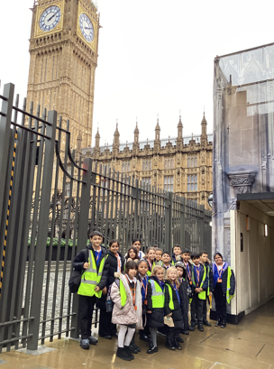
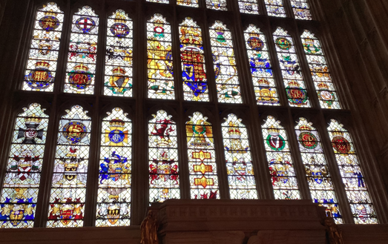


Reminder 
If you are celebrating your birthday, you can come to school dressed in your own clothes for the day!
*Please note that pupils are no longer able to bring in sweets, cakes or gifts.
Get involved!
If you have any suggestions of how we could make our school even better, please make sure that you speak to a member of the School Council.

Summer Term Plans
The School Council have been busy making plans ready for the summer term. The aim is to raise lots of money to support our new playground scheme OPAL (Outdoor Play and Learning). We are hoping to organise some fun days in school where we can support this important area of our curriculum to make our lunchtimes the best that they can be!

