
Reddal Hill Primary School
School Council Newsletter
Autumn Term 2025

Tel: 01384 569053 E: info@reddalhill.sandwell.sch.uk W: www.reddalhillprimary.com
Welcome to our first School Council newsletter. We are delighted to be the voice for our school.
This year is going to be an incredible year for School Council as we have lots of things lined up, including a trip to LONDON to the Houses of Parliament! We are going to tour the Houses of Parliament to see what the equivalent of our role in school is, but on an even bigger scale!


School Council
Please join me in congratulating our School Council members for the 2025/2026 academic year…
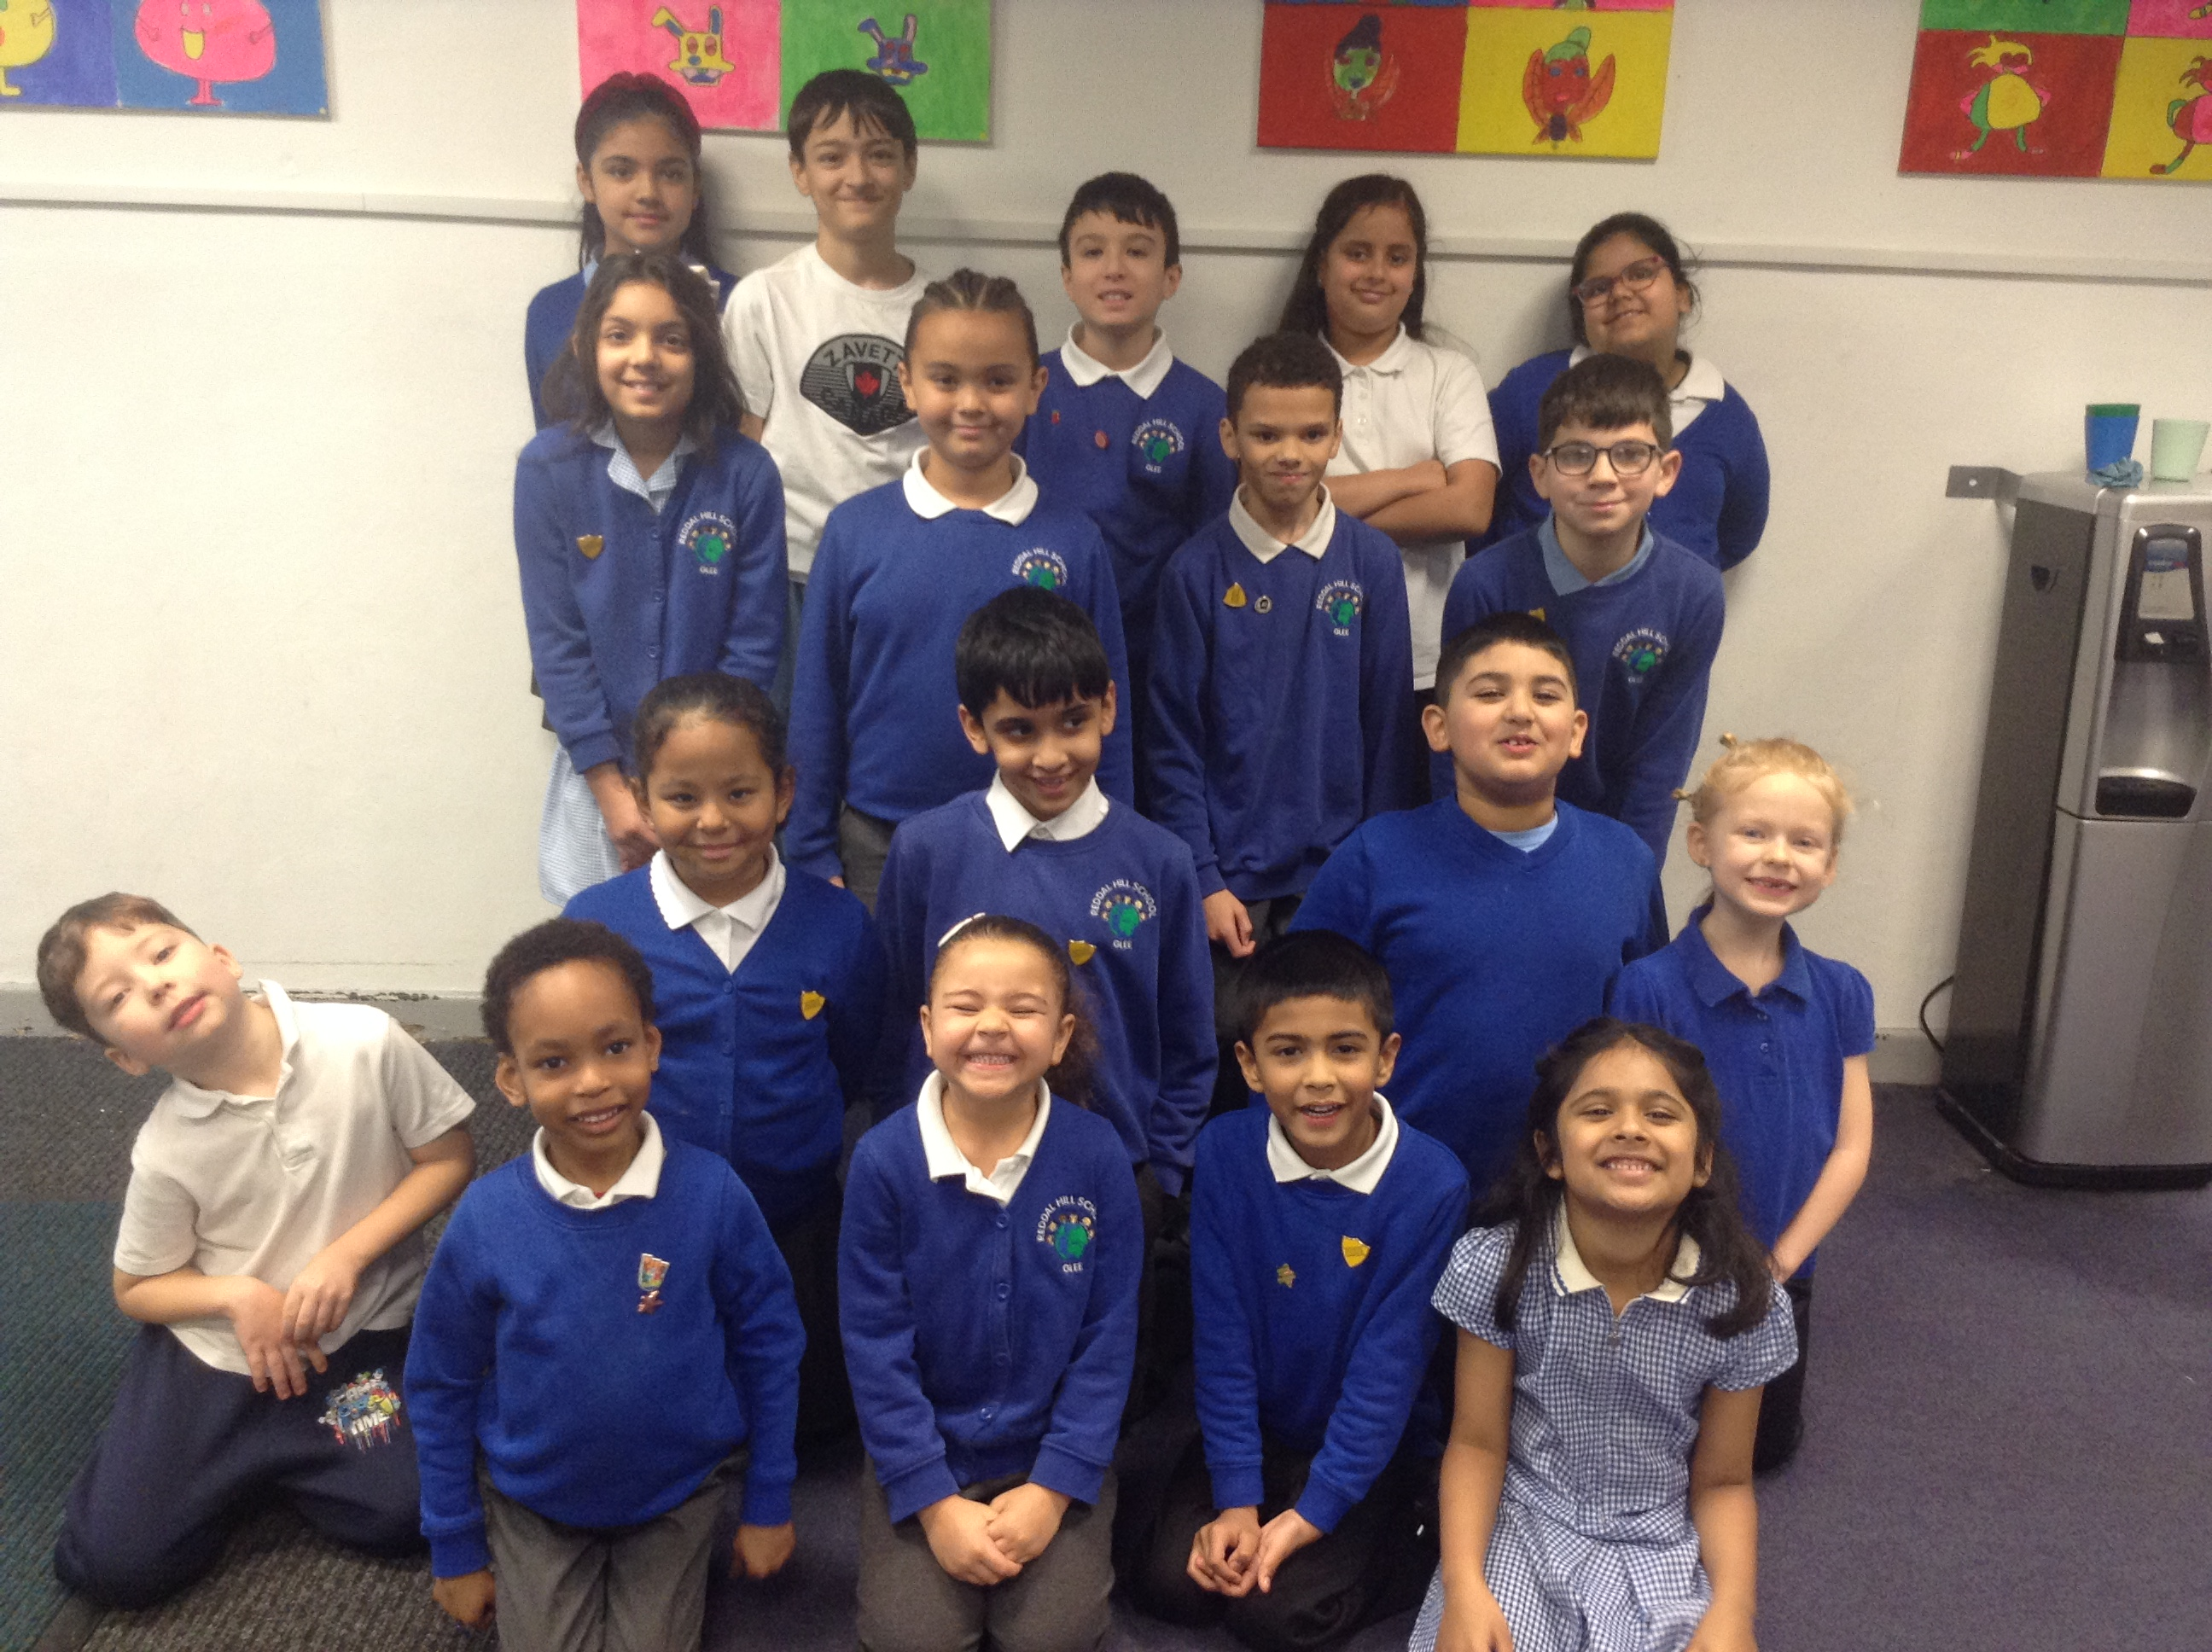

Spring Term Plans
The School Council have already met this year and have started to put together some ideas of how we are going to do some fundraising in school.
The money that we raise over the year, will help us improve our school with the suggestions made by our pupils.
We would like to support our new project in school – OPAL.

Get involved!
If you have any suggestions of how we could make our school even better, please make sure that you speak to a member of the School Council

Reminder 
If you are celebrating your birthday, you can come to school dressed in your own clothes for the day!

