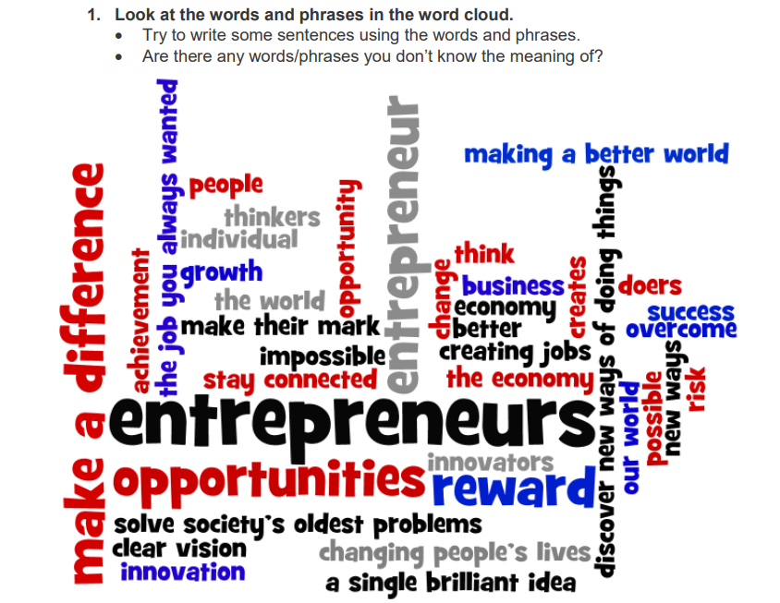

Sentences:

________________________________________________________________________________________________________________________________________________________________________________________________________________________________________________________________________________________________________________________________________________________________________________________________________________________________________________________________________________________________________________________________________________________________________________

Words I don’t know:

_____________________________

_____________________________

_____________________________

_____________________________

_____________________________

_____________________________

Now, use a dictionary to look up these words.

Word meanings:

________________________________________________________

________________________________________________________________________________________________________________________________________________________________________________________________________________________________________________________________________________________________________________________________________________________________________________________________________________________________________________________________