Look at the instructions given and find the features you have learnt in yesterday’s lesson.

Compare all of them then complete the questions below:

- Which set of instructions do you think are the best? Why? REMEMBER TO USE THE FEATURES TO HELP YOU MAKE YOUR CHOICE.
________________________________________________________________________________________________________________________________________________________________________________________________________________________________________________________________________________
- Which of the instructions were the worst and why? REMEMBER TO USE THE FEATURES TO HELP YOU MAKE YOUR CHOICE.

____________________________________________________________________________________________________________________________________________________________________________________________________________________________________________________________________
- How would you improve the set of instructions that were the worst?

____________________________________________________________________________________________________________________________________________________________________________________________________________________________________________________________________

How to make a dumper truck

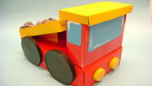
You will need:
- 1 large cereal box
- 2 small cereal boxes
- Shoe box lid
- Thin strip of blue paper
- 4 bottle tops
- Red and yellow paint to decorate
- 4 round lids
- Scrunched up newspaper
- Grey paint
- Black paint
- Sticky tape

Method:
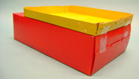 | - Cut the small cereal box in half, lengthways.
 | - Stick it on top of the larger cereal box using sticky tape on one side only.
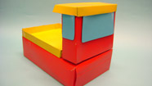 | - Cut the second small cereal box in half, widthways and stick this on the other end of the large cereal box, standing upright.
 | - Stick a shoebox lid on the highest part of the truck to make a roof.
 | - Stick a strip of blue paper just underneath the roof to make a window.
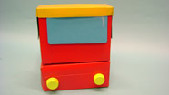 | - Stick two bottle tops onto the lower front of the truck to make the headlights.
 | - Paint the truck red and yellow.
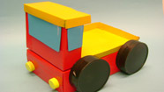 | - Paint four round lids black. When they are dry, stick them around the bottom of your truck to make the wheels.
 | - Scrunch up pieces of old newspaper and paint them grey to make some boulders for your truck to carry.

How to make a bird feeder

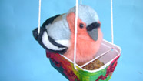
You will need:
- Margarine tub
- Different coloured paper or paint
- Glue
- Hole punch
- Wool

Method:

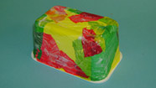 | - Empty the margarine tub.
 | - Decorate it by sticking on pieces of brightly coloured paper. Then wait for it to dry.
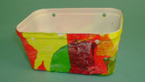 | - Use a hole punch to put four holes in the top of the margarine tub, so that you have two holes facing each other.
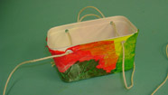 | - Thread some wool through each of the holes, and tie the two ends together.
 | - Finally, fill your birder feeder with bird food.
 | - Hang the bird feeder outside.

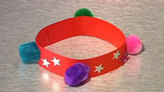
Friendship Bracelet
This should take about 15 minutes

You will need:
- Long strip of coloured, bendy card
- Stickers, coloured pom poms, and anything else to decorate!
- Glue

Method:
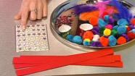 | - Cut out a long, thin strip of card.
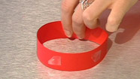 | - Stick the ends of the card together with some glue. This will make the shape of your bracelet.
 | - Decorate with stickers, coloured pom poms, and anything else you would like to use.
 | - Give to a friend.

How to Feed a Baby
Follow these simple steps to ensure your baby is well-fed and happy!
What you need:
• a highchair
• a bib
• baby food
• a bowl
• a spoon
• a microwave (optional)
• a cup of water or juice
• a clean cloth or towel
What to do:
1. Firstly, place the baby gently in the highchair and fasten their harness.
2. When in the highchair, put the bib around the baby’s neck.
3. Next, pour the baby food carefully into the bowl. If the baby
likes it warm, heat the food gently in a microwave.
4. Now, feed your baby small spoonfuls of the food.
5. Remember to give the baby sips of their water or juice frequently.
6. After they have finished their meal, wipe up any spills
and dribbles with the clean cloth or towel.
The baby should now be content and possibly ready for a sleep or maybe a nappy change.

How to Raise the Sky

Is your back so bent that your feet are the only horizon? Do you think the sky is too low? If the answer to this question is yes, read on and follow these simple instructions. Before you know it, you will have raised the sky!

What you need:

- Many long sticks and branches.
- Several balls of twine.
- A team of brave and determined friends.
- A large, open space.

What to do:

1) Firstly, collect many long sticks and branches from the forests. Remember to watch out for the wolves that prowl and pounce!
2) Once the sticks are collected, lay them carefully end to end.
3) After that, tie them together as tightly as you can with the twine. Aim to make several of the longest sticks you have ever seen!
4) Next, gather your team of brave and determined friends to take the long sticks to a large, open space.
5) As soon as everyone is ready, point the sticks upwards.
6) Finally, with all of your might, push and push and push. Before you know it, you will be able to raise the sky as high as you wish!
Top Tips

- Ignore the grown ups who say it is impossible. Remember, they do not know everything.
- Don’t give up if the sky does not give way. The brave and the determined try and try again!

