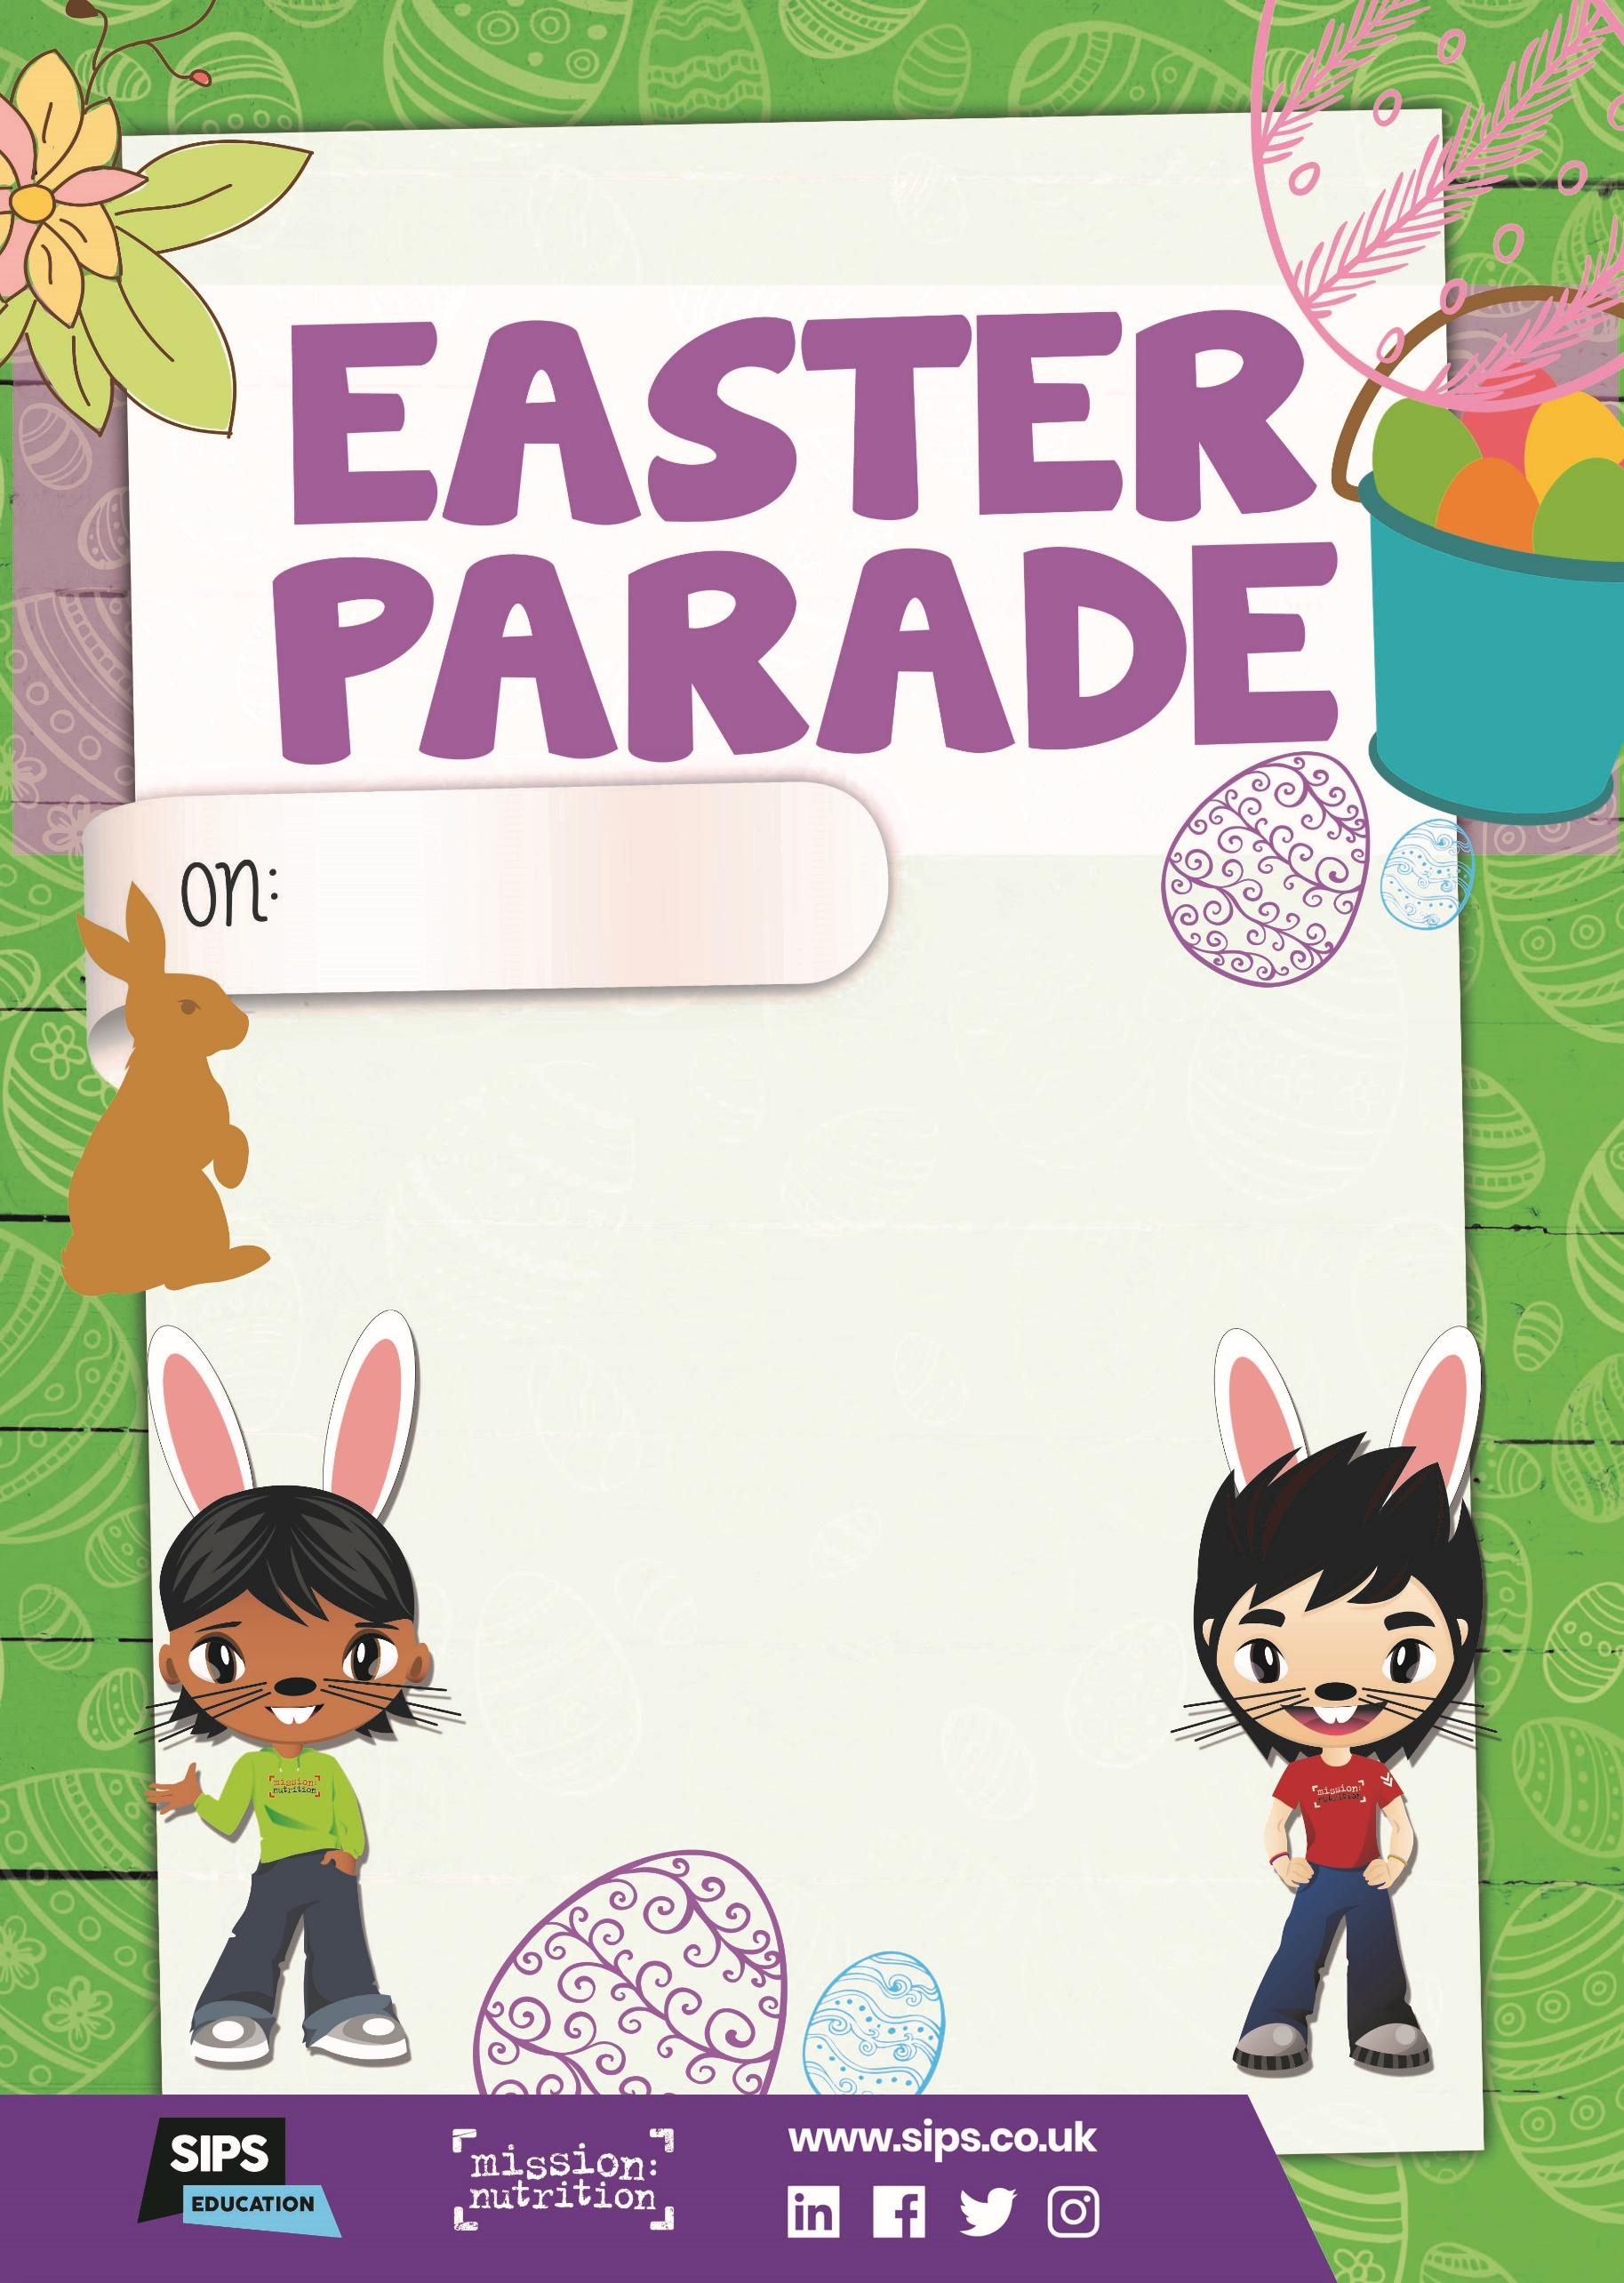
Tuesday 8th April

Roast Turkey and Gravy
Or Roast Quorn fillet and Gravy
Roast Potatoes
Broccoli
Carrots
***
Easter Biscuit
Or Fruit Yoghurt
Or Seasonal Fruit Salad

