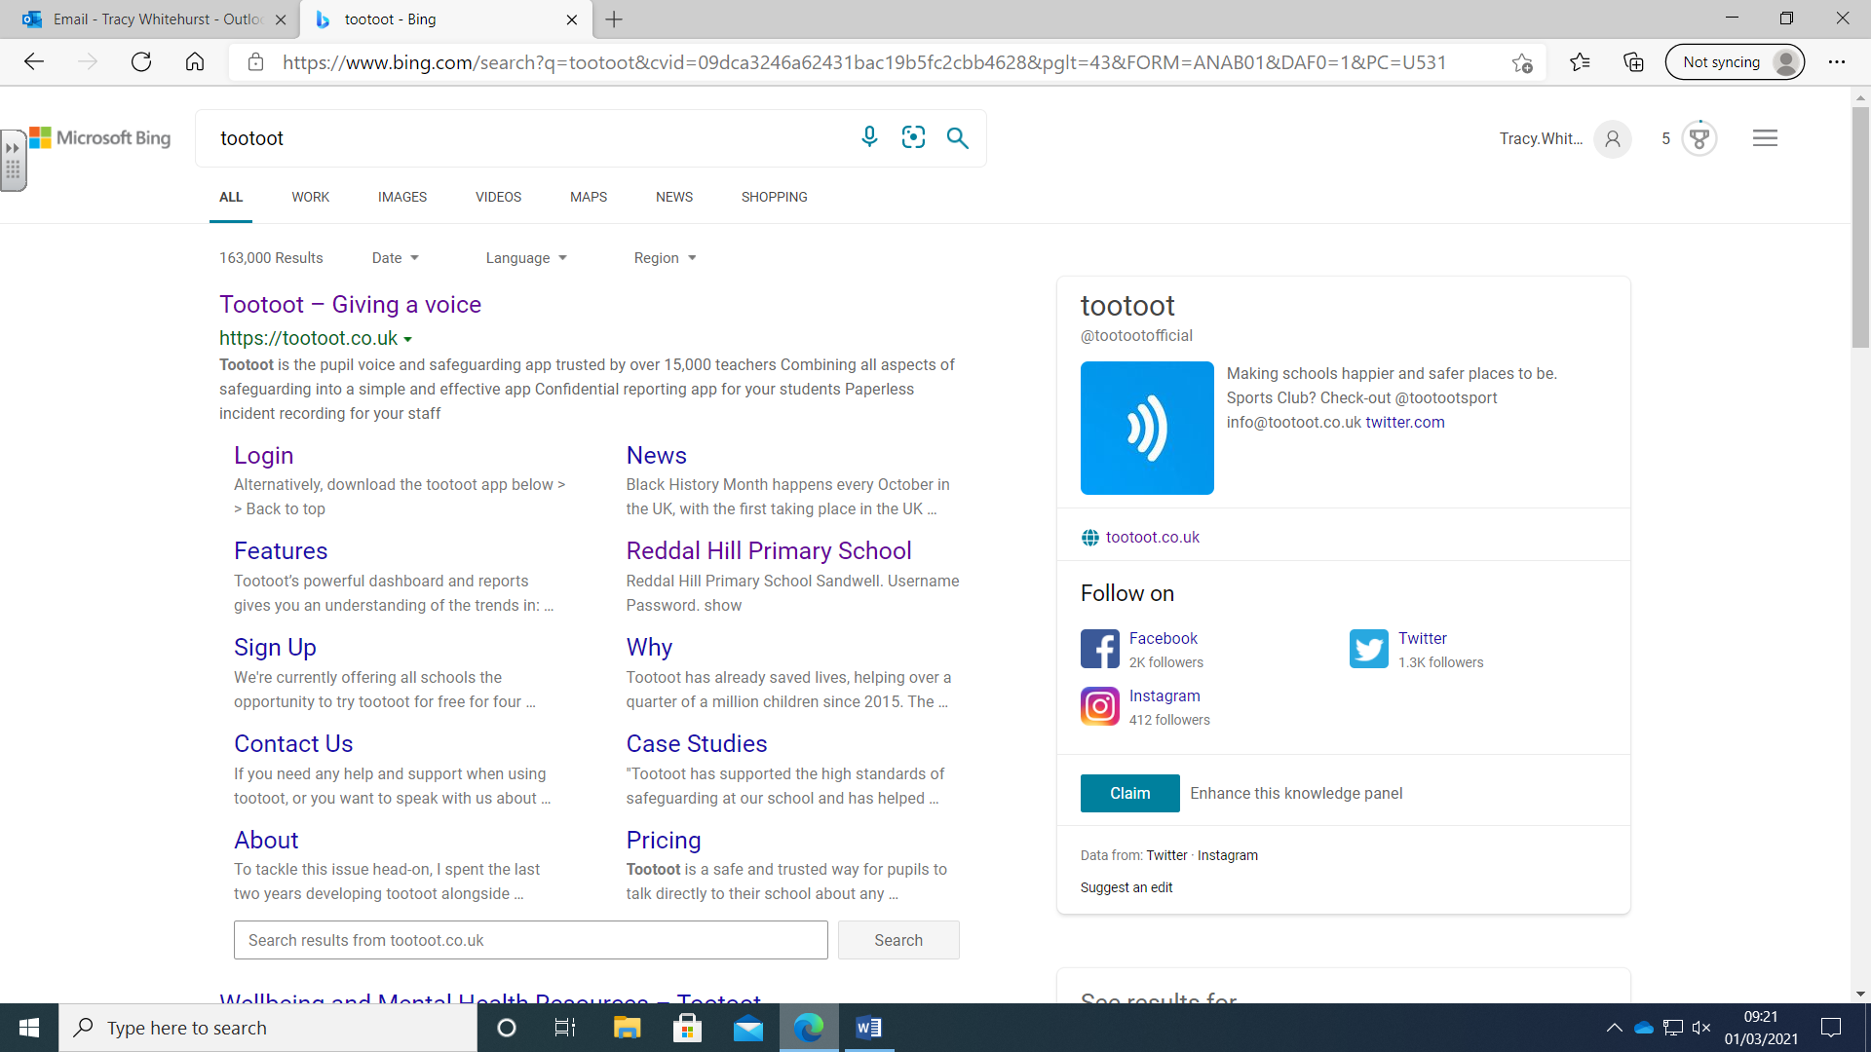**How to log into TOOTOOT**

TOOTOOT is an award-winning platform created to give children a voice at any time, even at weekends and school holidays.

If something is bothering you or if you’re not feeling yourself, send us a message and we will respond. (If it is out of school hours, we will do our very best to get back to you as soon as possible).

[**www.tootoot.co.uk**](http://www.tootoot.co.uk)

1. Click on the website link or type this into the web search engine.

**____________________________________________________________________**

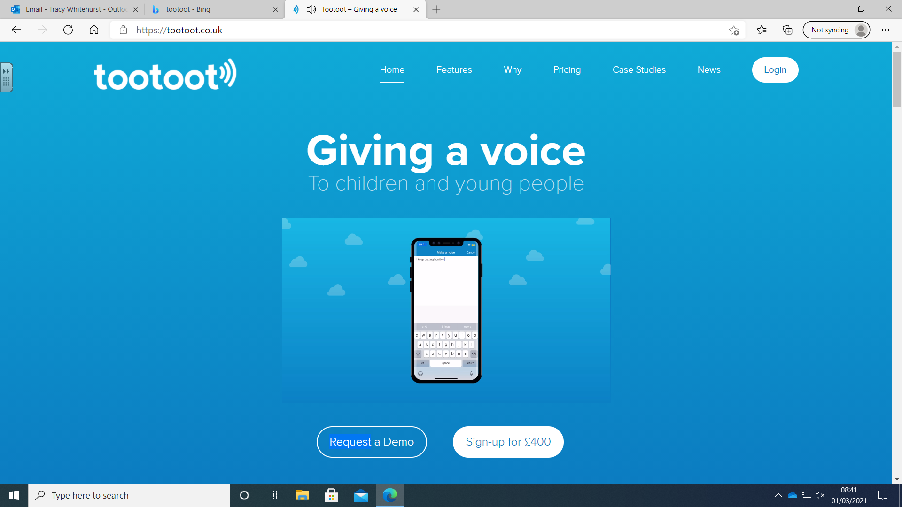

2. Click on ‘log in’.

**____________________________________________________________________**

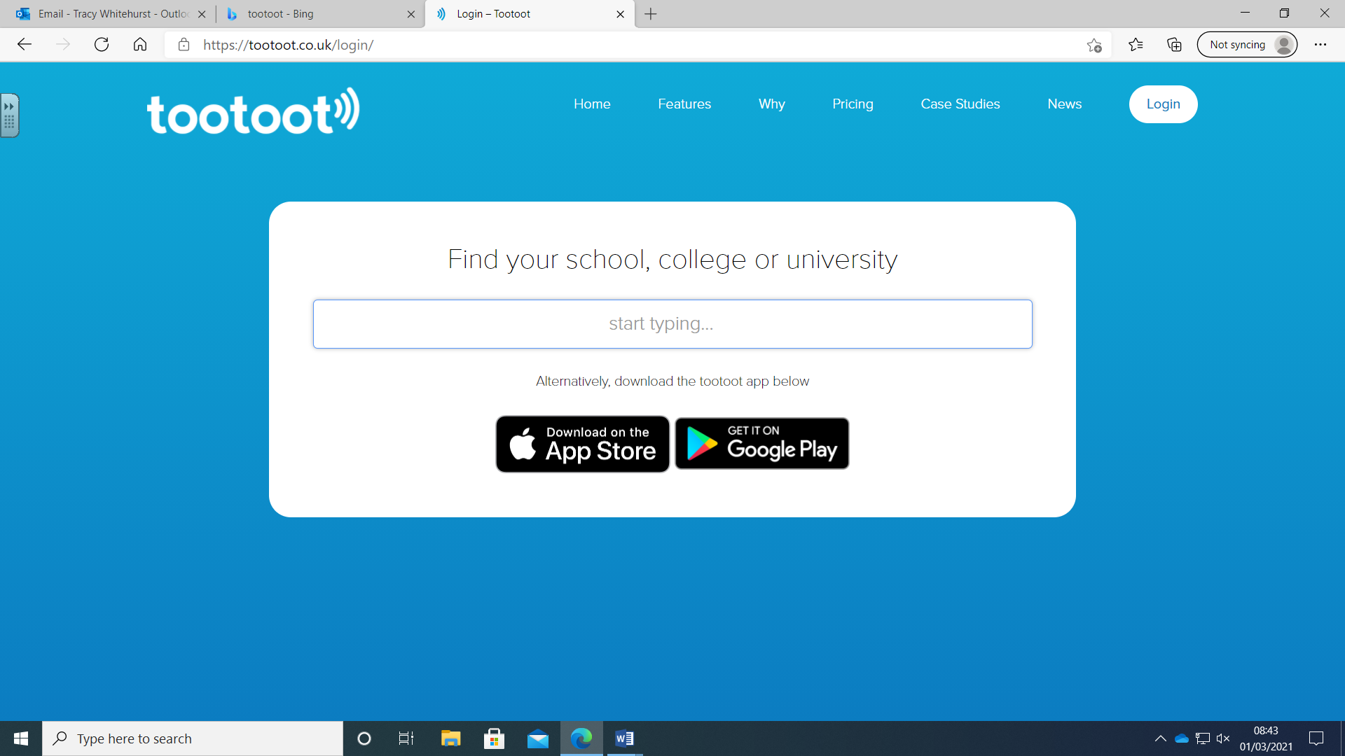

3. Type in the first few letters of Reddal Hill Primary School

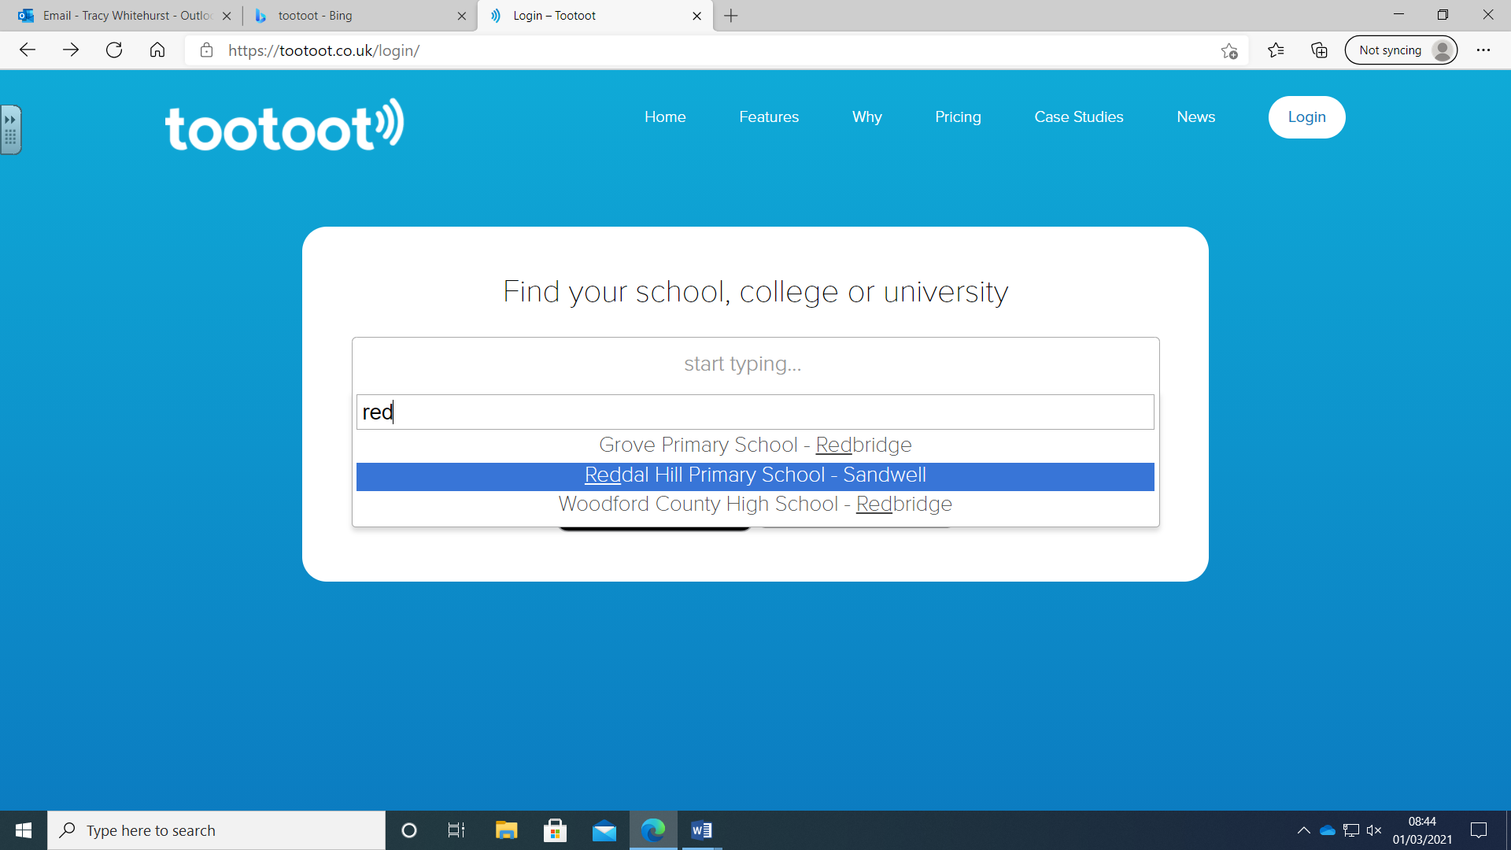

**____________________________________________________________________**

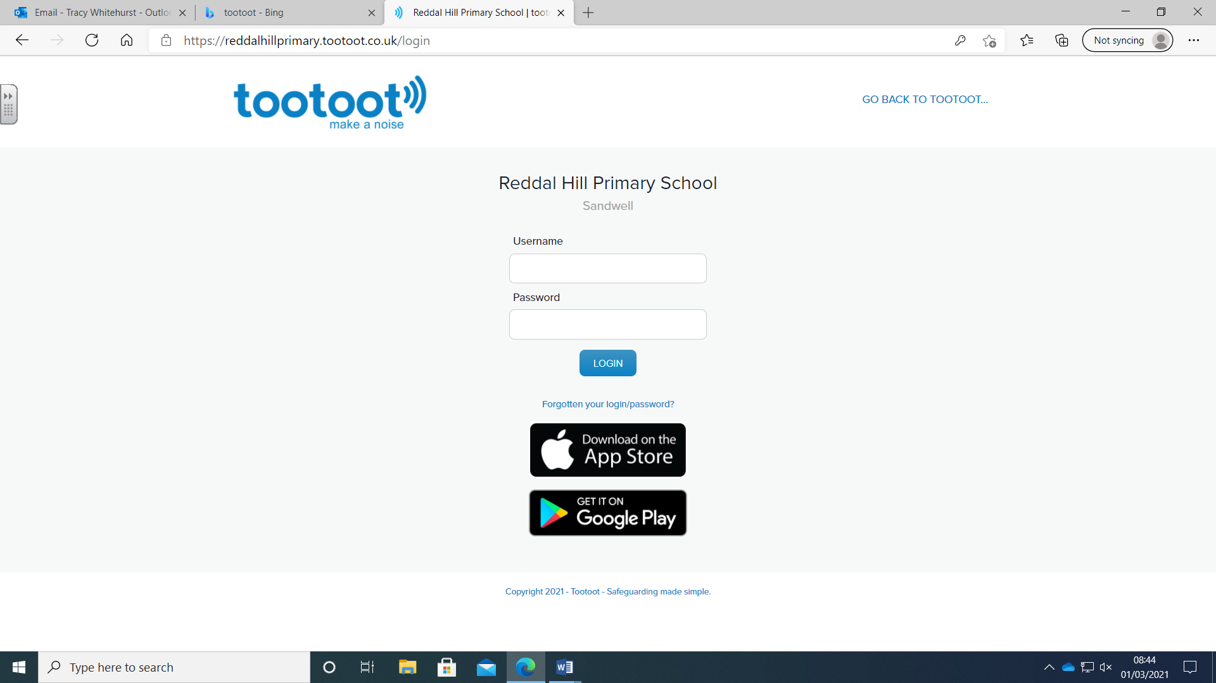

4. Type in your user name and password. This can be located on the log in card that you have been given. When you log in for the first time, you may be asked to change your password. Remember to write this down and keep it safe.

**____________________________________________________________________**

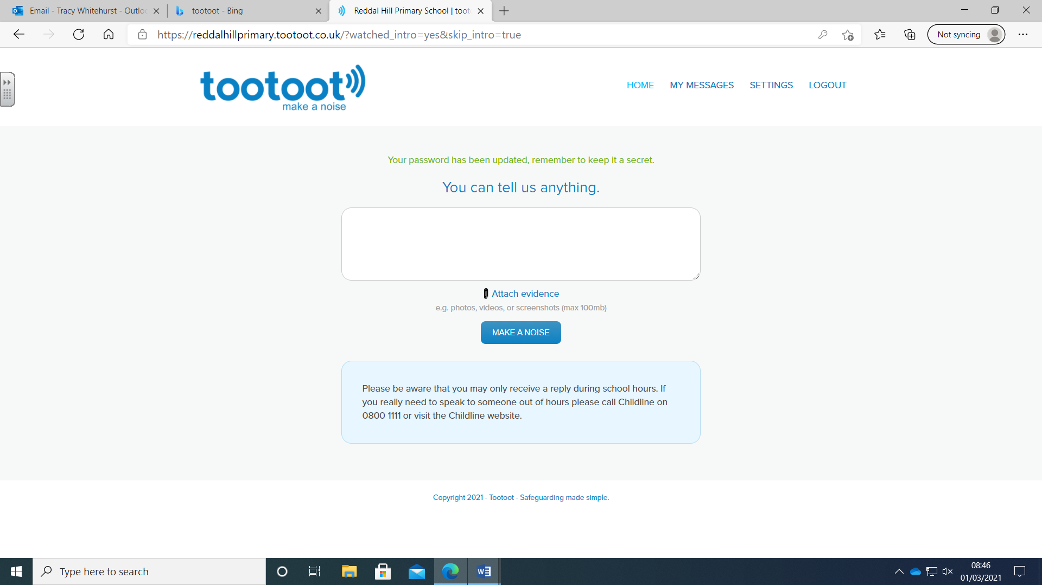

5. Type your message in the box. You can also attach a document. When you have finished click ‘MAKE A NOISE’.