Monday 26th February 2024

Dear Parents/Carers,

On **Friday 8th March** we will be celebrating World Book Day in school. For this day your child is welcome to dress up as their favourite book character, bring in their favourite book from home or can wear comfy clothing to simply get comfy for reading!

The children will also take part in a range of fun activities during the afternoon in their classes.

We look forward to seeing and hearing all about the books your children love!

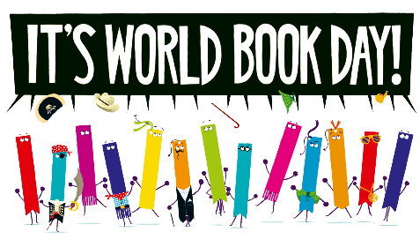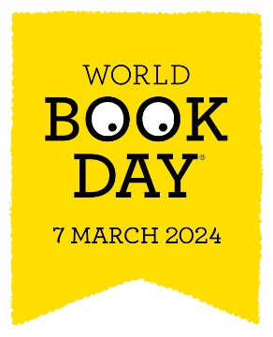Thank you,

Mrs Passey