Wednesday 5th February 2025

**Word of the Month**

Dear Parents/ Carers,

We are excited to introduce a new initiative for this academic year: **‘Word of the Month.’**

This initiative is designed to enrich our school community’s vocabulary by introducing new and exciting words. Our goal is to encourage both pupils and staff to incorporate these words into their conversations and written work.

What makes this initiative special is that **our pupils choose the words!** Each class has suggestion slips where pupils can submit ideas for the next **Word of the Month.** The pupil who has been selected for suggesting the most interesting/ creative word will receive a **prize from our book basket.**

To further encourage engagement, pupils who use the **Word of the Month**—either in conversation or in their writing—will be awarded a raffle ticket. During our **Word of the Month assembly,** we will draw a winning ticket from each phase, and the selected pupils will receive a **prize from the book basket.**

You’ll find **Word of the Month** posters displayed around the school, and we’ll also share updates on **ClassDojo. (See below).**

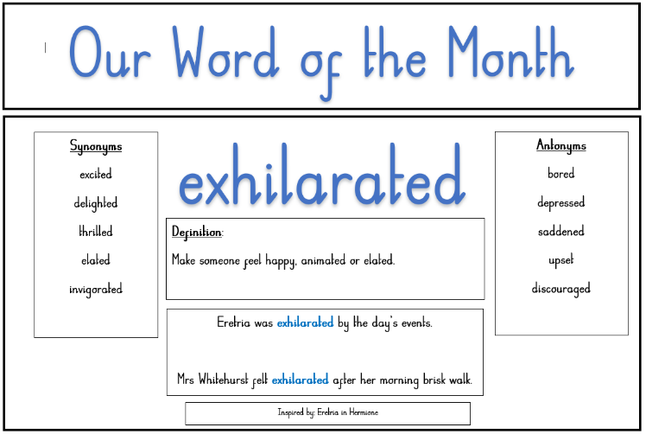

Thank you in advance for your support in making this initiative a success!

Well done to all the pupils who have won a prize for their word choice and improved vocabulary.

Kind regards,

Hayley Rogers

Assistant Headteacher (responsible for Reading)