Monday 30th September 2024

Dear Parents / Guardians,  
  
There is an increasing issue with childhood obesity and tooth decay, and as we aim to be a Healthy School, we want to support parents as much as possible to make healthy choices for their children’s meals. A healthy meal is important because it will help children to:

*Be fitter and healthier now and later in life;

*Learn quicker and show positive behaviours;

*Maintain a healthy mental health, leading to a happier life.

Over the last couple of weeks there have been a number of difficulties with some of the items coming in children’s packed lunches so I would like to clarify our expectations.  
**Where possible, packed lunches should include:**  
*One portion of pasta salad, sandwich, bread roll or pitta bread.*Cooked meat or boiled egg as a filling in a sandwich.*One portion of fruit and vegetables e.g. carrot/cucumber sticks, cherry tomatoes, apple, banana etc.*One portion of yoghurt or cheese.*One drink of water or a sugar free juice.We also recommend children eat fruit or yoghurt as their pudding choice. However, cereal bars, raisins or **one small** chocolate bar can be eaten. As we are a nut free school food items **must not** contain nuts or nut traces.

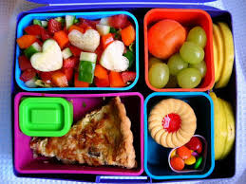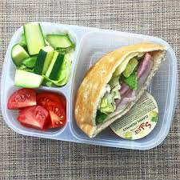**Examples of a good packed lunch**

**Example 2**

**Pasta pot**

**Cheese square**

**Carrot sticks**

**Cereal bar**

**Example 1**

**Ham/cheese/egg/pasta/jam/tuna Sandwich**

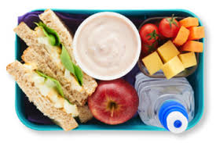**Yoghurt**

**Apple/grapes/banana**

**Small chocolate bar.**

During break time, your child should be provided with a **healthy nut free snack** such as fruit, plain popcorn, a yoghurt or a healthy cereal bar.

Thank you for your continued support.   
Mrs Fazey   
Healthy Schools Coordinator