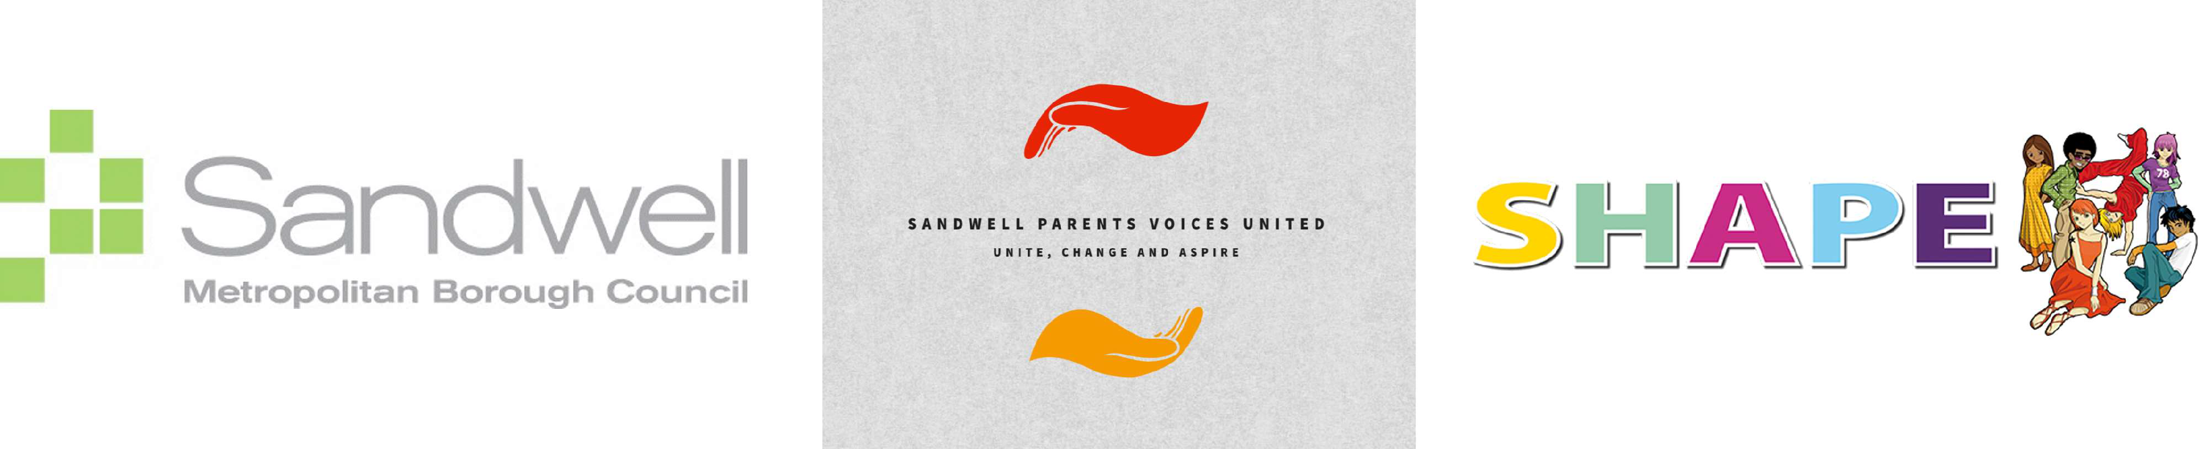

Public Health

Sandwell Council
Freeth Street
Oldbury
B69 3DE

10.01.25

Ref: SEND (special educational needs and disabilities) Survey for parents

Dear Parent/Guardian,

Sandwell Parents Voices United (SPVU) are working in partnership with Sandwell Council’s child voice initiative, the SHAPE Programme, to develop a SEND Co-production charter. Both SPVU and SHAPE would like your support in developing this charter so that we can hear the voices of children and young people, and parent carers.

To understand the needs of parents who have children with SEND, there are a series of questions which we would like you to answer. The closing date of the survey is 4pm on Friday 24th January.

There are several methods which you can use to complete the survey:

- The preferred and method is online at the following link: https://online1.snapsurveys.com/SENDsurvey
- For anyone who is not able to complete an online version of the survey, a paper version of the questionnaire can be printed at school reception. You will need to let them know if you have more than 2 SEND children so additional sheets can be printed. These will need to be completed and handed back to school reception by end of the school day on Friday 24th January 2025.
- For anyone who needs additional support to complete the forms, SPVU can be contacted at admin@spvu.org and they will be able to arrange a time with yourselves to come and complete the online form with you.

Also attached is a flyer for an invitation for the first SEND Parent Carer and Young People’s Co-Production Event taking place on Wednesday 29th January from 6.30pm – 8.30pm at Brasshouse Community Centre. If you are interested in attending please email admin@spvu.org.

Kind Regards

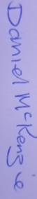
Neesha Patel Daniel McKenzie
SHAPE Programme Manager Sandwell Parents Voices United
neesha_patel@sandwell.gov.uk daniel.mckenzie@spvu.org
07980 955011 07923 352516

