Thursday 19th September

Dear Parents/Carers,

On Thursday 26th September, the PTA are hosting the **Macmillan Coffee Afternoon** to help fundraise money for this amazing charity.

This will be held in the dining hall from **2:30pm** and we would like to invite all parents and carers to come along and enjoy an afternoon of hot drinks and cakes!

There will be a range of cakes on offer and the PTA would just like to ask for a donation to put towards the Macmillan charity. All cakes will be labelled with the correct allergen information.

There will also be a raffle to win a giant cookie or some cupcakes baked by some of our amazing teachers at school! Raffle tickets will be available to purchase on Thursday 26th September at **8:30am** by the **main school gate.** They will be **£1** for a strip of raffle tickets. The raffle will then be drawn during the coffee afternoon and the lucky winners will get to take their goodies home!

Thank you for your continued support. We look forward to seeing a number of you there!

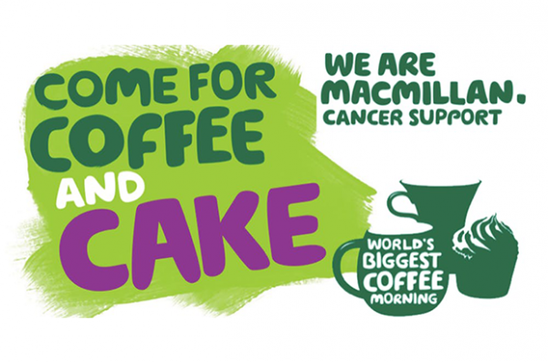The PTA Team