Thursday 13th March 2025

Dear Parents and Carers,

Reddal Hill Eco Council are once again supporting the local charity, ‘Kids Clothes Project’, to supply free clothing packages to families in need across the Black Country. In November, we were able to support around 28 families with your kind donations!

Our eco councillors will be running a **donation day** on **Wednesday 9th April 2025** and would warmly welcome any of the following donations:

Yes please to:

 Good quality, clean children’s clothing (including coats and pyjamas) aged 2-12yrs

 Clean, undamaged cuddly toys or games (with all working parts) and books

 Children’s bags / rucksacks

 Pairs of good quality shoes tied together

No thanks to:

* Underwear

Please note that adult clothes are also warmly welcomed, but these will be sold by weight to help cover the charity’s running costs rather than distributed directly.

Our eco councillors will gratefully collect any donations from your child’s classroom on that day.

***If you know of a family who would benefit from a children’s clothing bundle, please contact Mrs Nisbet, via the school office, who can arrange this****.*

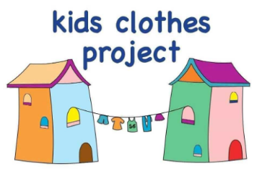Thank you for your support,

Mrs L. Harrold

KS2 Phase Leader and Eco School Lead