14th January 2025

Dear Parents/Carers,

After the success of last year’s book fair, we would like to invite you to another **Scholastic Book Fair sale** in the **school hall.** The book fair will be open every afternoon, **after school,** from **Friday 7th February until Wednesday 12th February.**

Please see the attached book fair poster, identifying a small selection of the books that are on sale. You can also look at the amazing range of books that Scholastic sells by visiting their website: [www.shop.scholastic.co.uk](http://www.shop.scholastic.co.uk)

Your child will be given their £1 World Book Day voucher in advance of the event, so that these can be used towards a quality book from the fair.

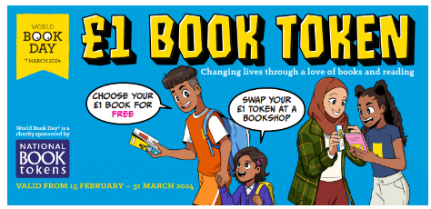

We will also be running a reading competition whereby your child could win a £5 voucher to spend at the book fair! Watch this space!

The most preferred way to pay for the books would be using cash, however, there will be a QR code that will enable parents/ carers to pay, using their phones.

We look forward to seeing you there!

Kind regards,

Mrs Rogers

Assistant Headteacher (Reading Lead)

